# **O365 Authentication – Microsoft Authenticator setup to mobile**

To set this method up it first consist of 3 stages, the first is install Microsoft authenticator on you mobile, the second is join the app to your account so it knows it is you and your device, the 3 is to login to O365.

Once setup and configured, you only have to do stage 3 every 60 days to re-authenticate.

## Stage 1 – Install Microsoft authenticator on your mobile

1. On your mobile goto the Play store or apple store
2. Locate Microsoft authenticator app (has icon below)

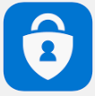

1. Download the app onto the mobile

## Stage 2 – Authenticating your mobile to your O365 account

1. Open Google chrome
2. Type **portal.office.com** in the address bar



1. Enter your email address [firstname.surname@jehall.co.uk](mailto:firstname.surname@jehall.co.uk) then click next

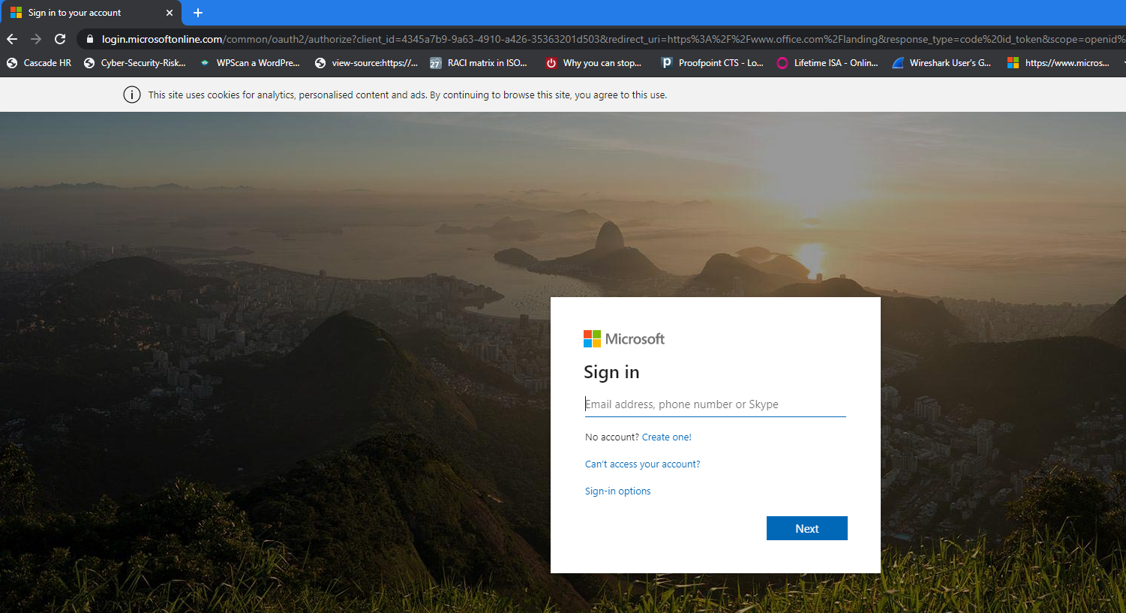

1. If prompted click on work or school account

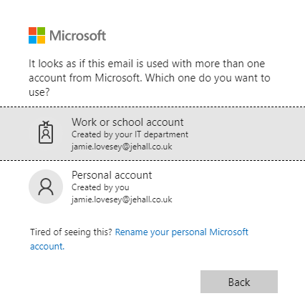

1. The below screen will appear clearly showing the J&E Hall logo, this is to validate it is our portal you are logging onto. Enter your password, this is the same one you use to log onto your PC. Then Click Sign in

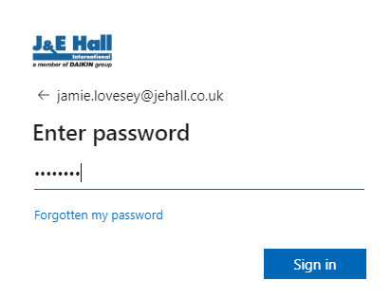

1. Click on next

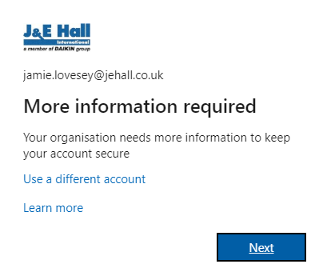

1. Click on Next

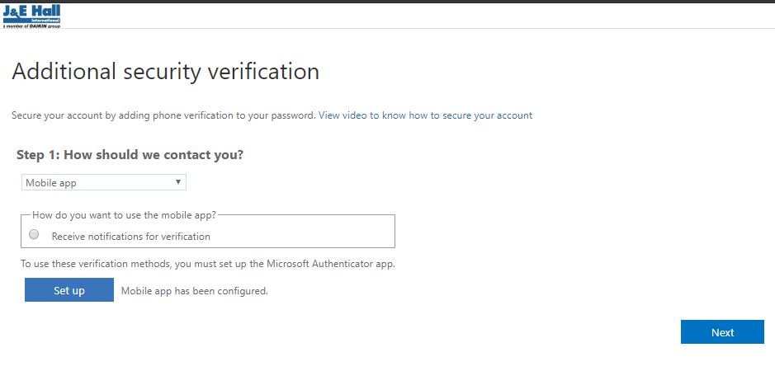

1. Click on Setup

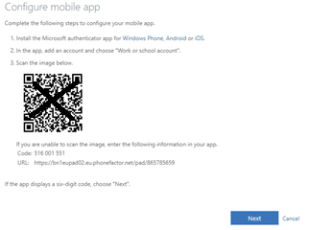

**DO NOT** SCAN THE CODE ABOVE IN THIS DOCUMENT. USE THE ONE ON YOUR SCREEN FROM THE SETUP AS EACH USER WILL HAVE A UNIQUE CODE WITHIN THEIR IMAGE

1. On your mobile open the app, Microsoft authenticator and scan the barcode

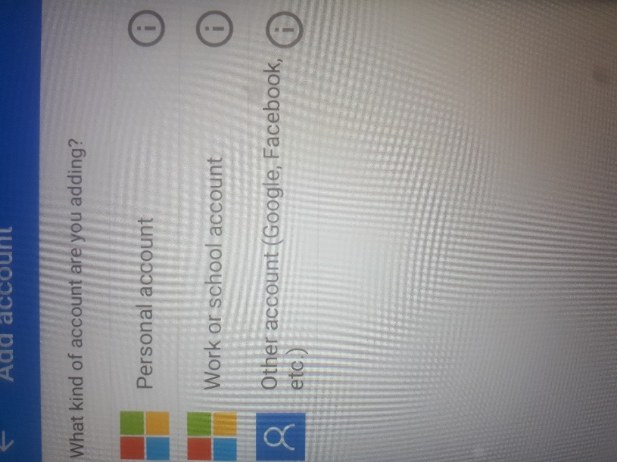

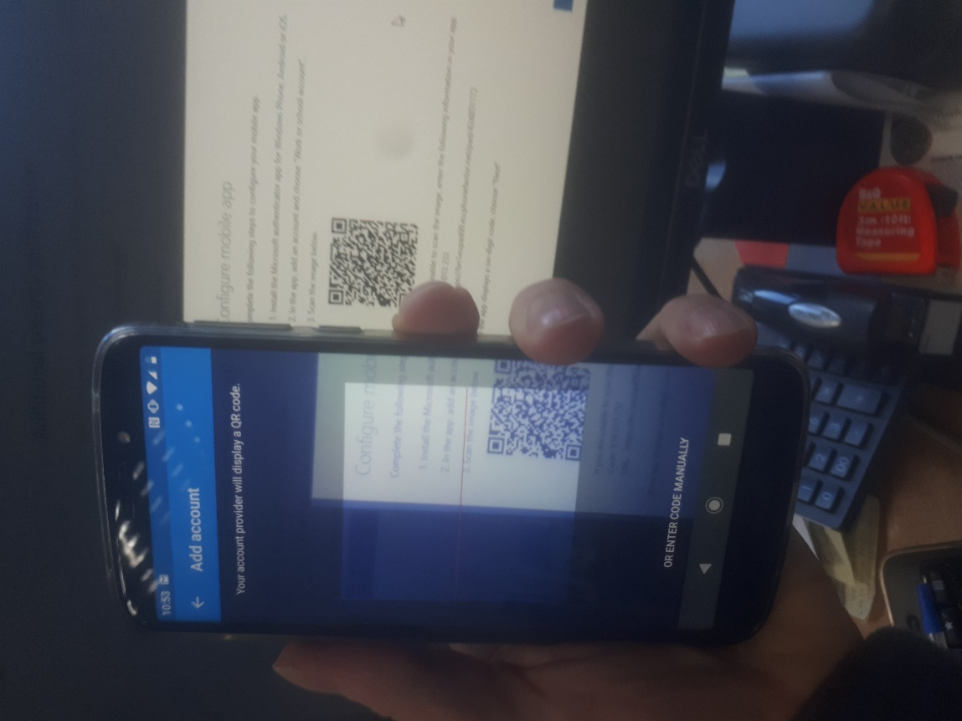

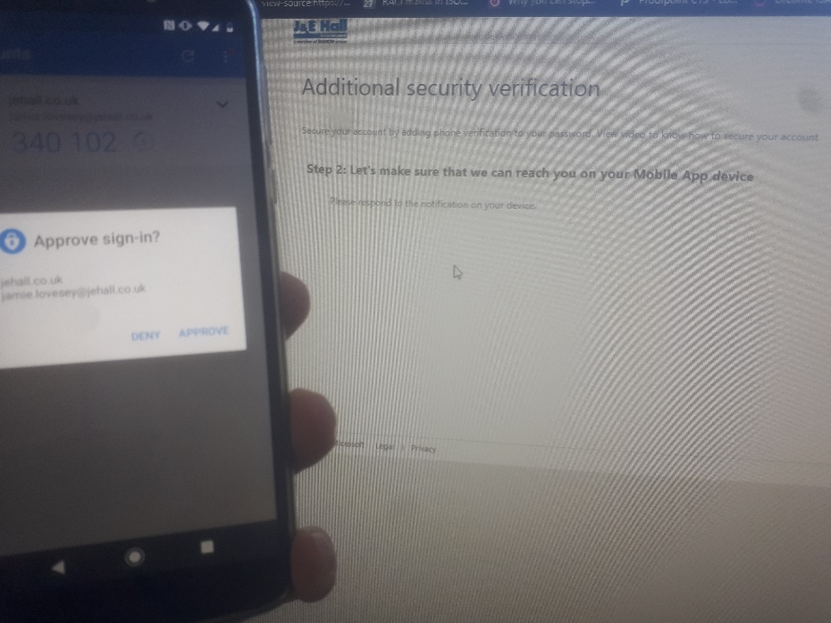

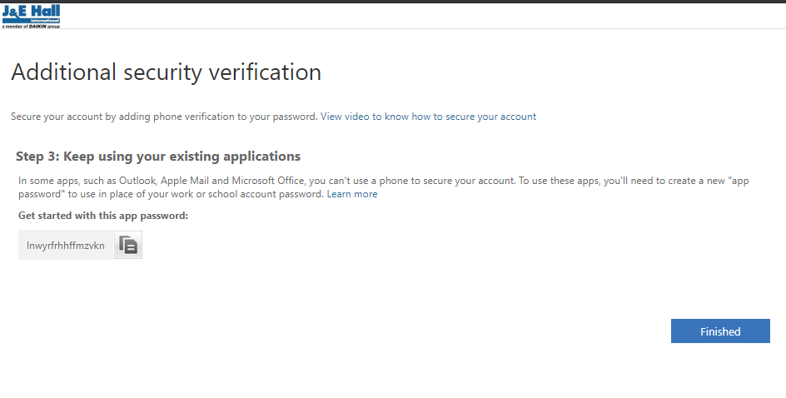

1. Click Yes to stay signed in, this will then remember you for 60 days before you then have to repeat this authentication process.

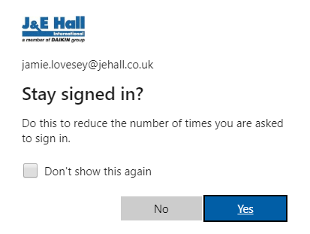

1. Once you click on Yes, you will successfully login and the office portal screen below will appear in your web browser

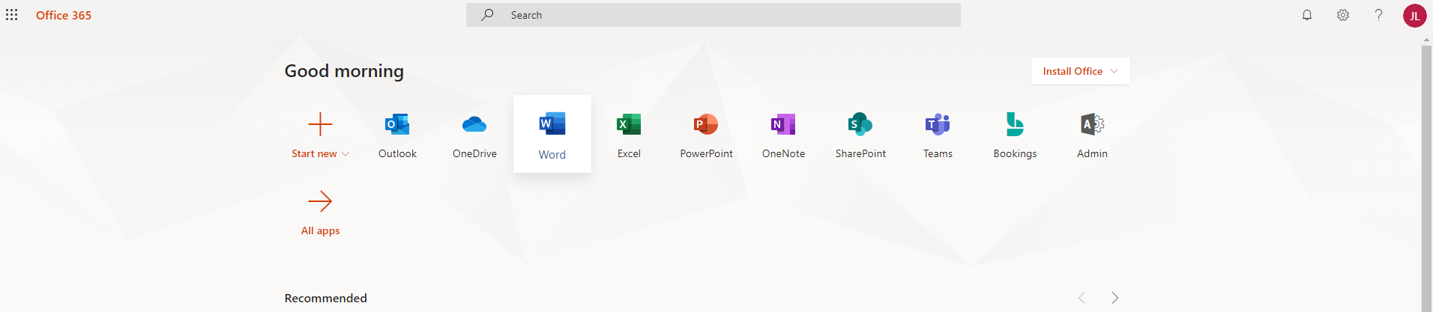

## Stage 3 Login using the app

1. Open Google chrome
2. Goto portal.office.com



1. Enter your email address [firstname.surname@jehall.co.uk](mailto:firstname.surname@jehall.co.uk) then click next



1. Now click on work or school account



1. The below screen will appear clearly showing the J&E Hall logo, this is to validate it is our portal you are logging onto. Enter your password, this is the same one you use to log onto your PC. Then Click Sign in



1. The screen below will appear, click done ask again for 60 days.
2. Then on your mobile click on approve to authenticate access

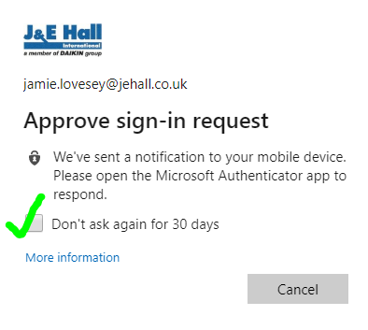

1. Click on Yes and then the portal will appear.

