# **O365 Authentication – Text message pin method**

1. Open Google chrome
2. Type **portal.office.com** in the address bar



1. Enter your email address [firstname.surname@jehall.co.uk](mailto:firstname.surname@jehall.co.uk) then click next

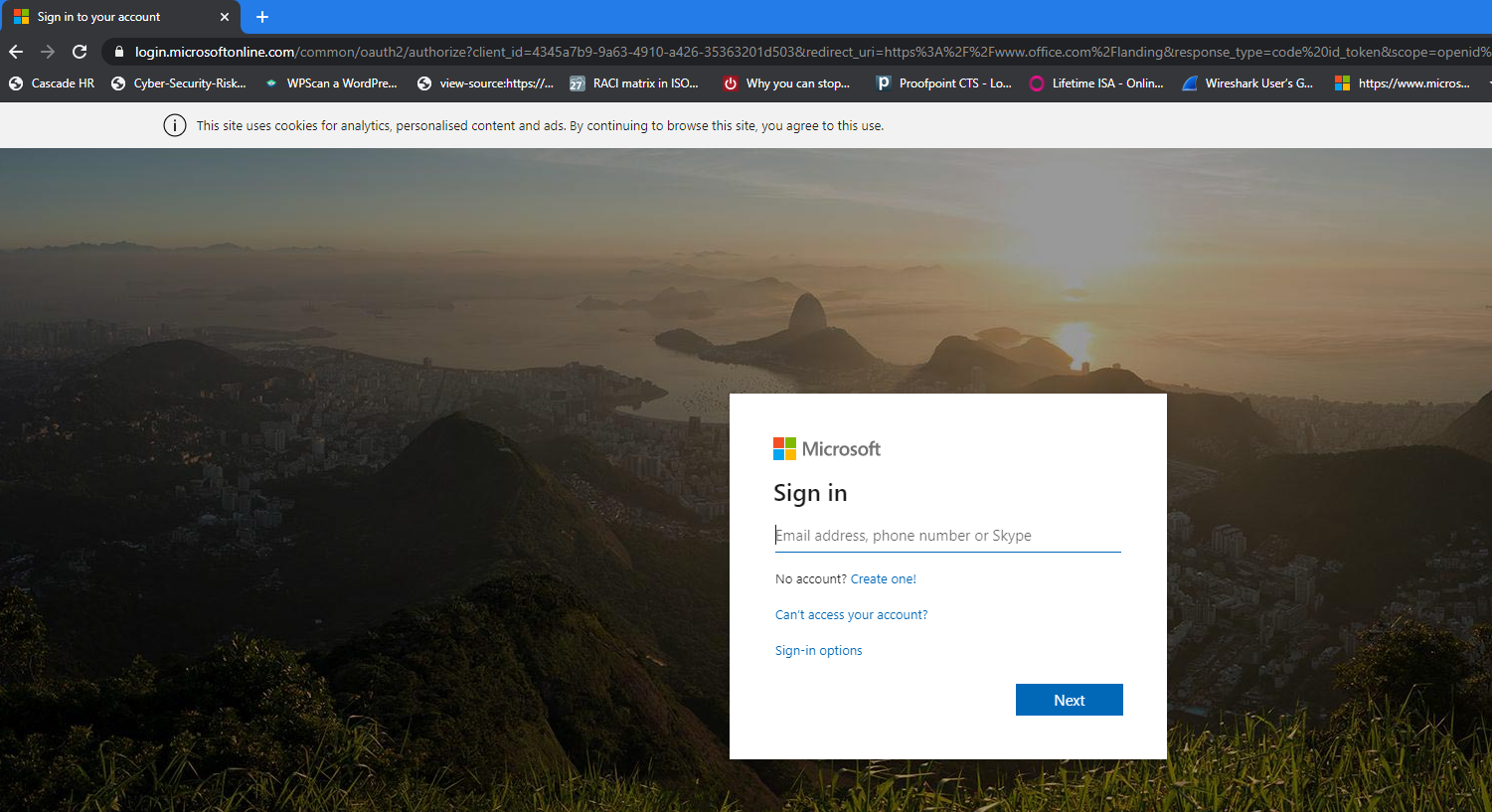

1. If prompted click on work or school account

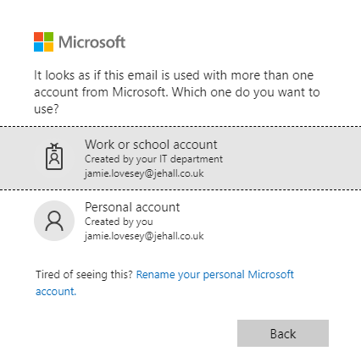

1. The below screen will appear clearly showing the J&E Hall logo, this is to validate it is our portal you are logging onto. Enter your password, this is the same one you use to log onto your PC. Then Click Sign in

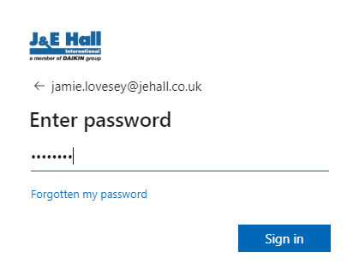

1. Click on next

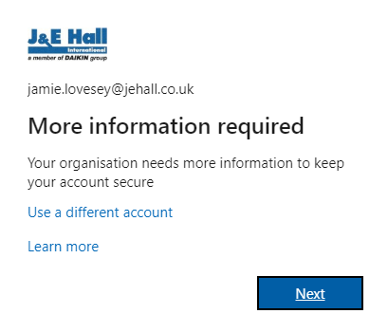

1. Check the mobile number is correct, then click Next. A Text message will be sent you your mobile.

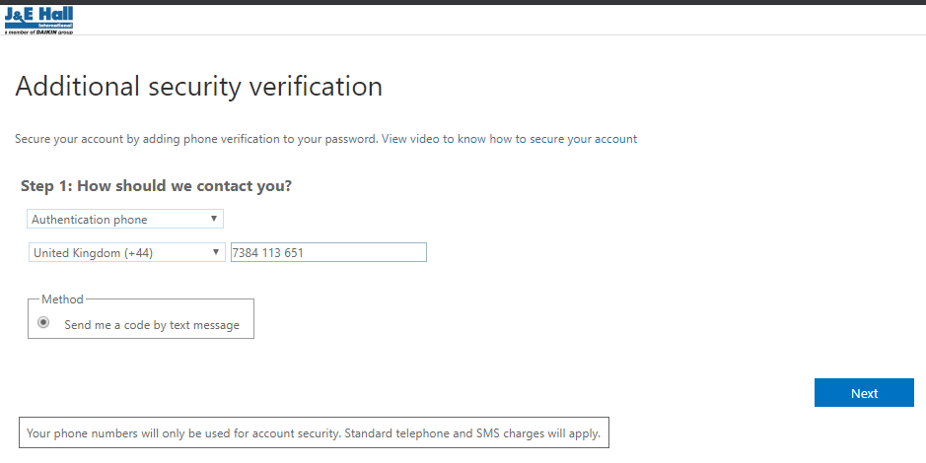

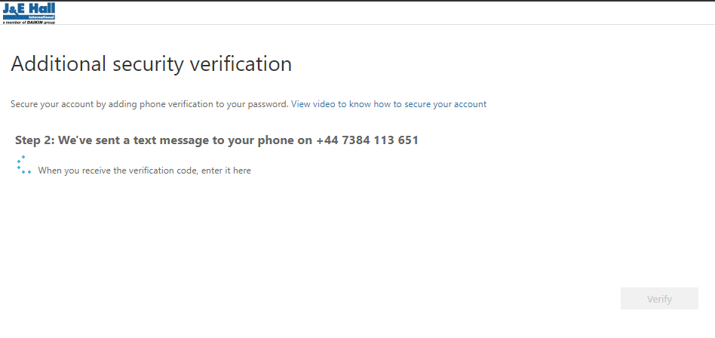

1. Check you mobile for the text, and enter the unique 6 digit pin received

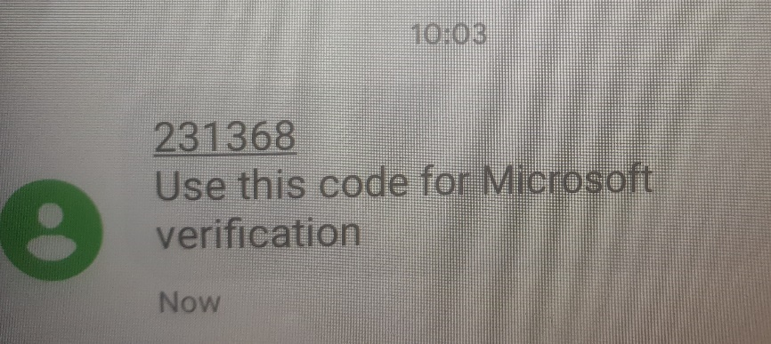

1. Enter the 6 digit code in the box and then click verify

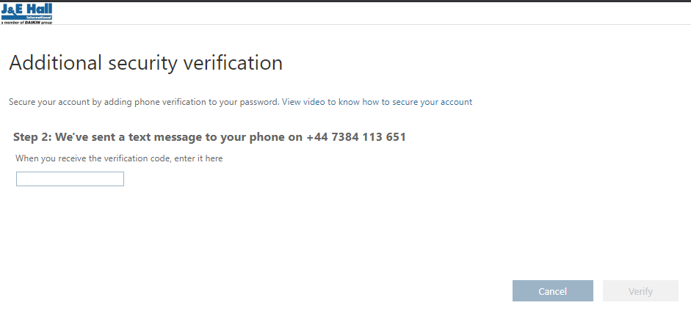

1. Then click on finish on verification screen below.

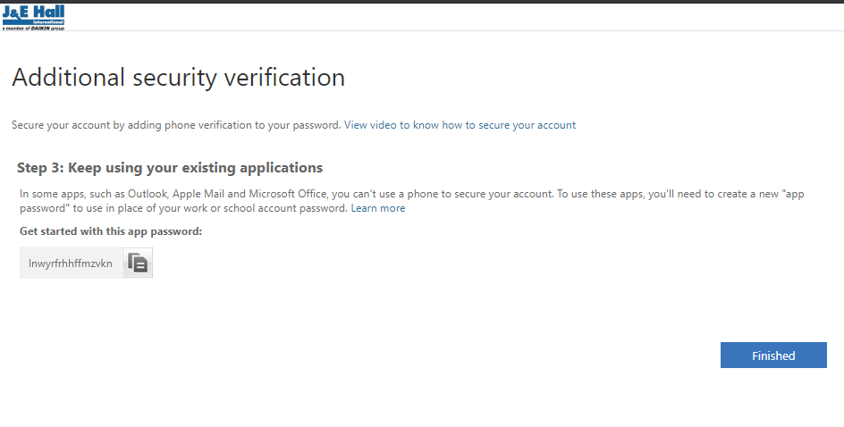

1. Click Yes to stay signed in, this will then remember you for 60 days before you then have to repeat this authentication process.

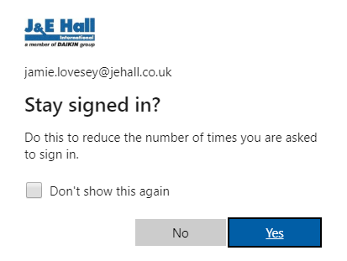

1. Once you click on Yes, you will successfully login and the office portal screen below will appear in your web browser

