**Installing the Outlook App on an Android Phone – Meraki Work Profile**

1. Download the Microsoft Outlook App from the **Play Store**

<https://play.google.com/store/apps/details?id=com.microsoft.office.outlook>

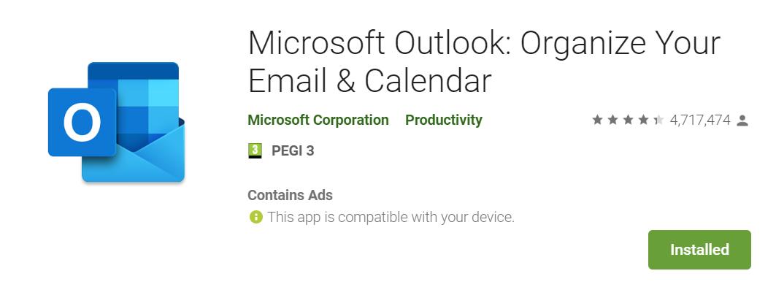

1. Click **Install** and the app will install to your phone
2. Run the app and click **Get Started**
3. Enter your work **email address**

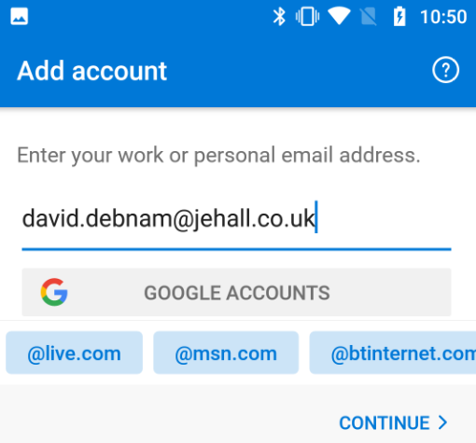

1. Enter your **password**. This is the same as the one you log onto your PC with. Select **Sign In**

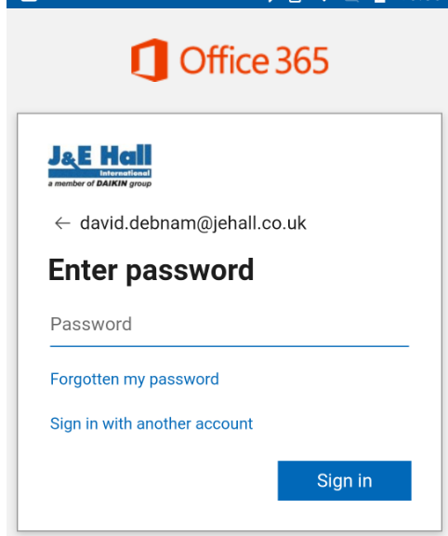

1. The next screen is Approve Sign-in Request and will verify your identity

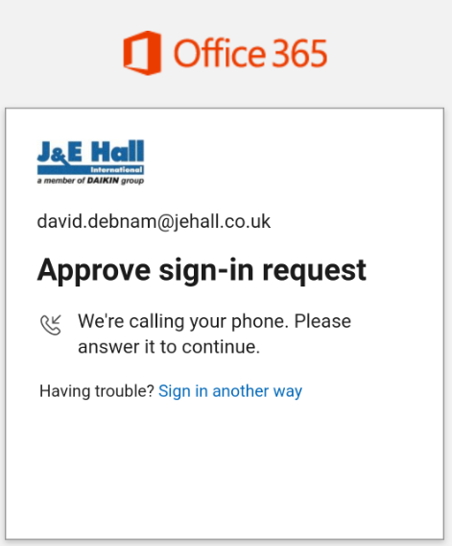

You phone will ring and you will have to accept the request by pressing # on your phone. This is much like the two-factor verification you have already setup

1. Activate the device by selecting **Activate**

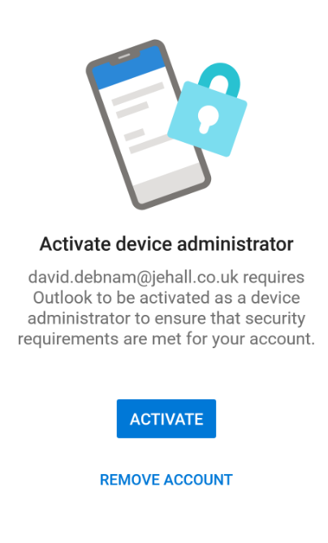

1. From the next screen select **Activate this device admin app**

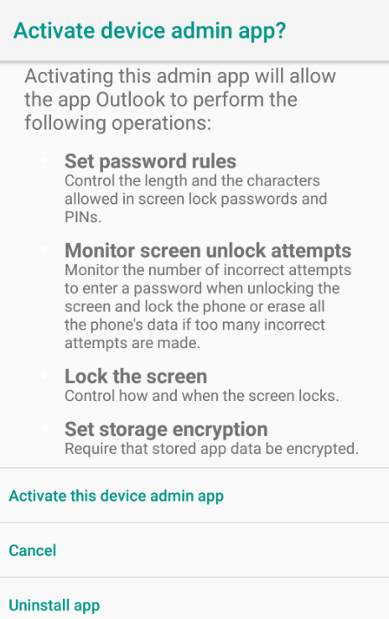

1. The next two screens select **skip** on both

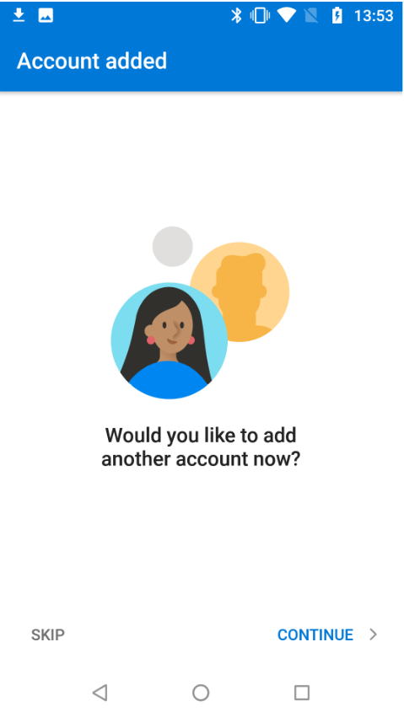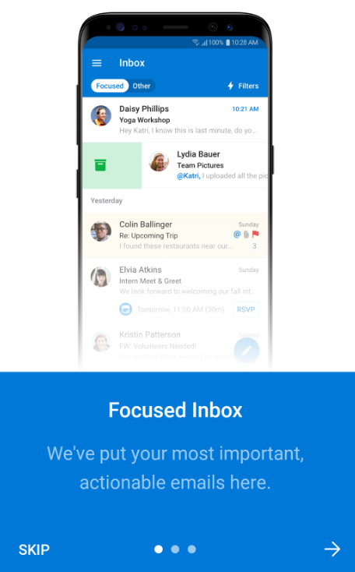

1. Now to enable the contacts to be synced from Outlook to the device, select the **three horizontal lines** at the top

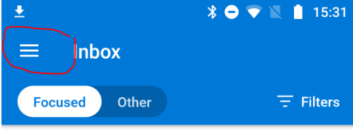

1. Select the cog icon

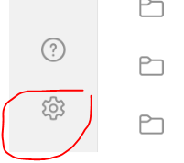

1. Select your email address at the top

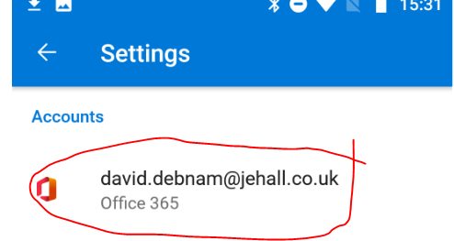

1. Slide the Sync Contacts bar across

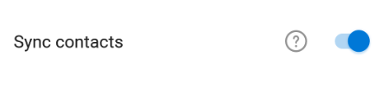

Your contacts will then sync across shortly.