# **O365 Webmail access (replacement for OWA)**

N.B This will authenticate you onto the device you are logging onto today for 50+ days, before asking you to redo the process when loggino in again. For each new device you login into to access webmail it will ask you to reauthenticate that new device and the 50+ day count down will then start for that device separately.

1. Open Google chrome
2. Goto outlook.office.com
3. Enter your email address [firstname.surname@jehall.co.uk](mailto:firstname.surname@jehall.co.uk) then click next

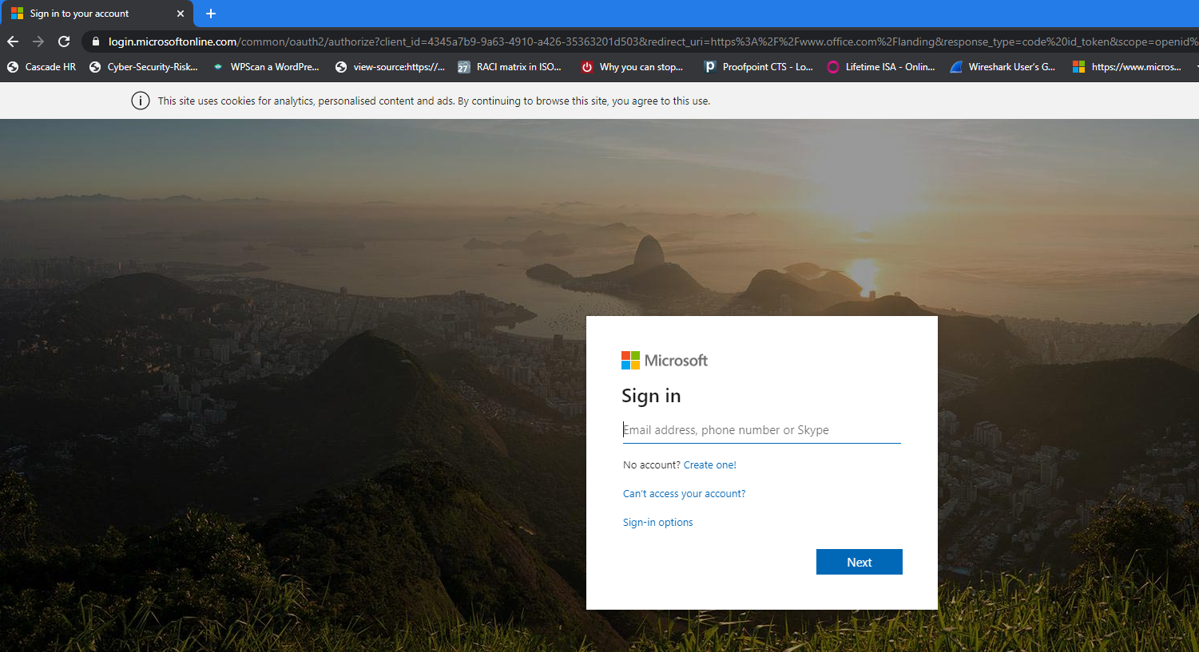

1. Now click on work or school account

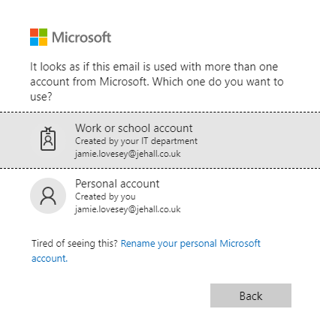

1. The below screen will appear clearly showing the J&E Hall logo, this is to validate it is our portal you are logging onto. Enter your password
2. Click Sign in

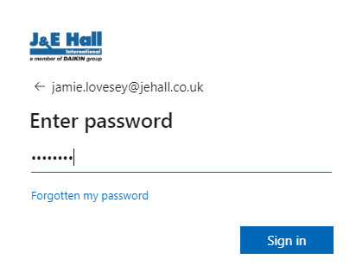

1. Click on next

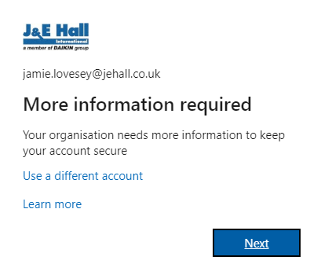

If setup to text, it will text you a code to enter. Type the code in below. And tick the box

Alternatively click on sign in a different way if you don’t have you mobile on you. And it will give you other options to authenticate, text, phone call, mobile app

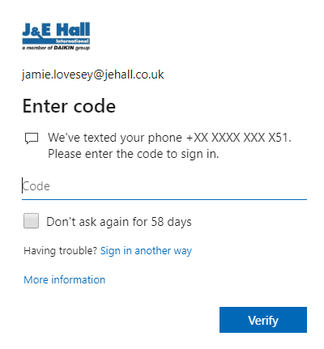

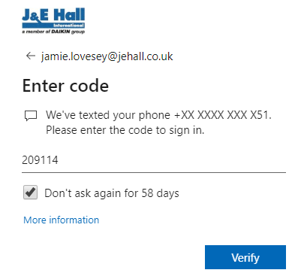

Now click on verify.

Click on no

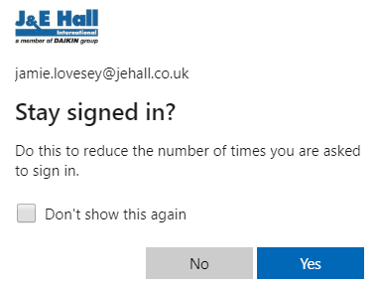

Webmail will now load and open in your web browser on your laptop, desktop, or mobile phone

