**O365 Updating Outlook after Email Update**

When your emails change over you will need to restart Outlook

You may then be prompted to resign into your account

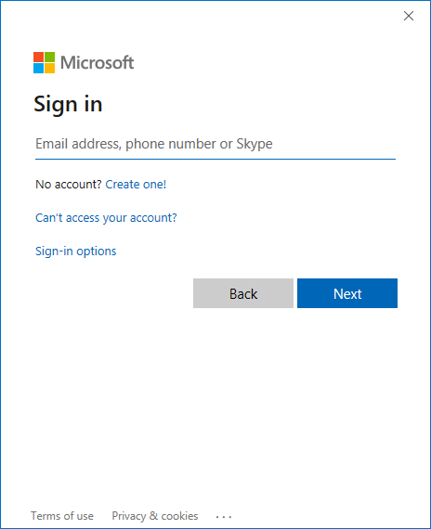

If you get prompted with the following screen, please check to see what account you are being signed in as, if it starts jehint as highlighted below, then this is the old account you need to select **Sign in with another account**

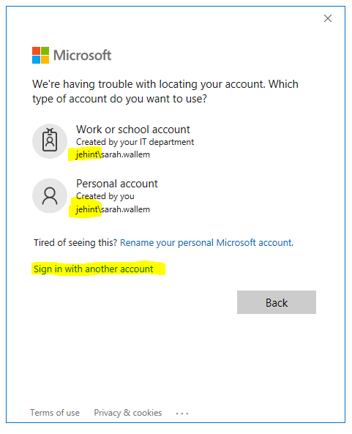

It will prompt to login and have JEHINT\firstname.surname.

Delete this and enter your email address, [firstname.surname@jehall.co.uk](mailto:firstname.surname@jehall.co.uk) **then click next**



The below screen will appear clearly showing the J&E Hall logo, this is to validate it is our portal you are logging onto. Enter your password, this is the same one you use to log onto your PC. Then Click **Sign in**

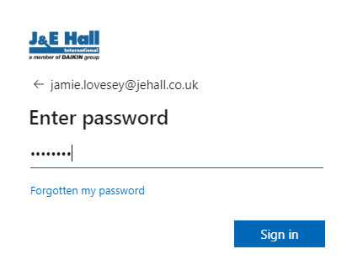

The final stage will verify your login, this will involve a call to the phone you previously setup for two factor verification.

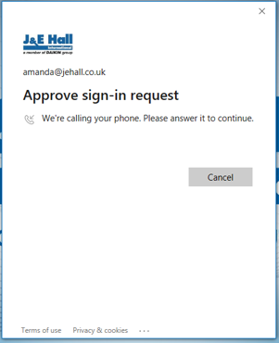

Please answer and follow instructions to complete the setup. Outlook will then load as before